Data Acquisition and Manipulation Using SQL
Course-End Project-1
Akansha Chowdhury

Employee Performance Mapping

A new database was created –
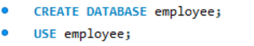
All three datasets where imported under this database employee –
- emp_record_table: It contains the information of all the employees.
- Proj_table: It contains information about the projects.
- Data_science_team: It contains information about all the employees in the Data Science team.
The data column “START_DATE” and “CLOSURE_DATA” in Proj_table where changed into yyyy-mm-dd format before importing it into the database.
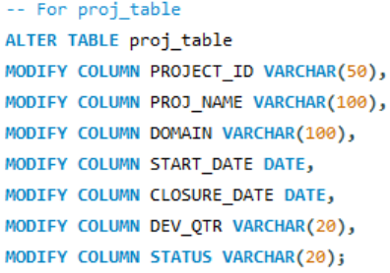
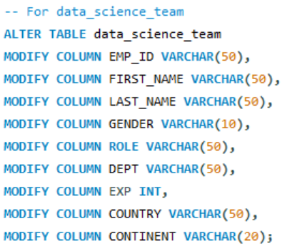
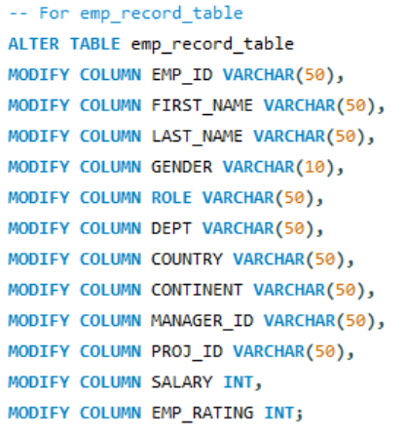
Then the table columns datatypes were changed from “TEXT” to the relevant datatypes

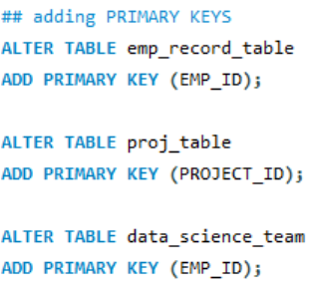
The primary keys are assigned accordingly –
This completes the first task
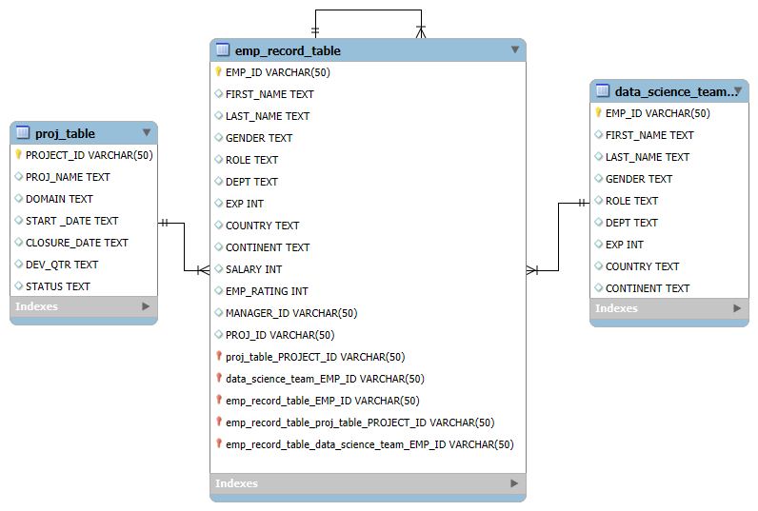
Task 2 was to create ER diagram for the given employee database
The 3 task was to write a query to fetch EMP_ID, FIRST_NAME, LAST_NAME, GENDER, and DEPARTMENT from the employee record table, and make a list of employees and details of their department
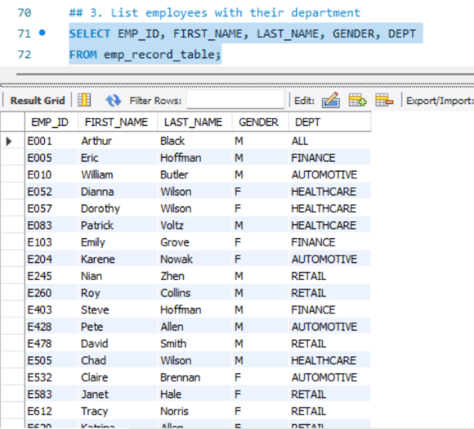

Task 4 was to write a query to fetch EMP_ID, FIRST_NAME, LAST_NAME, GENDER, DEPARTMENT, and EMP_RATING if the EMP_RATING is:
- less than two
- greater than four
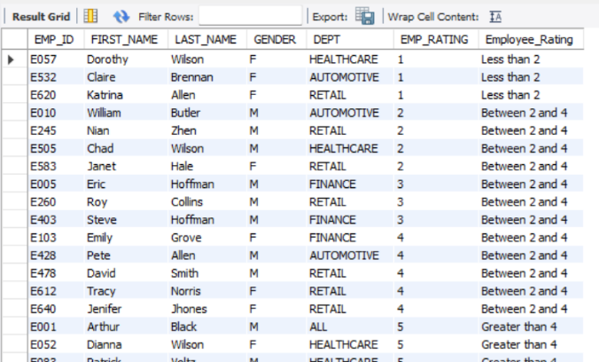
- between two and four
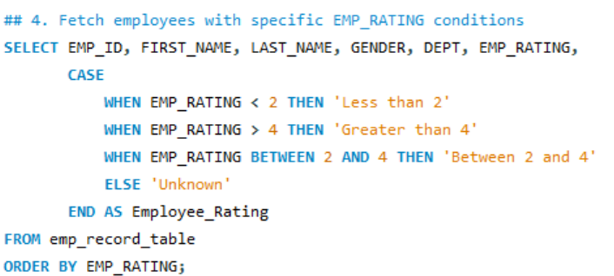
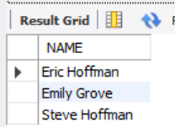
Task 5 was to write a query to concatenate the FIRST_NAME and the LAST_NAME of employees in the Finance department from the employee table and then give the resultant column alias as NAME.
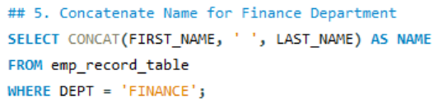
Task 6 was to write a SQL query to retrieve the employee ID, first name, role, and department of employees who hold leadership positions (Manager, President, or CEO).
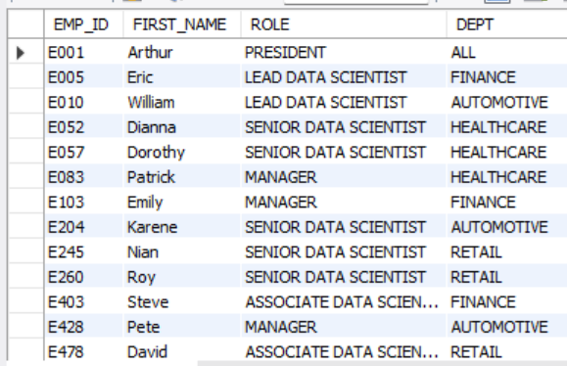
Task 7 to write a query to list all the employees from the healthcare and finance departments using the union. Take data from the employee record table.
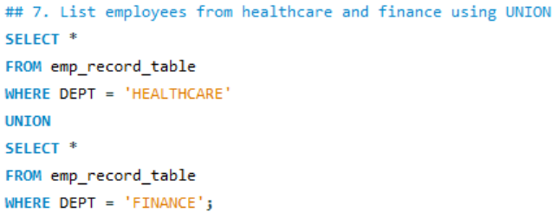
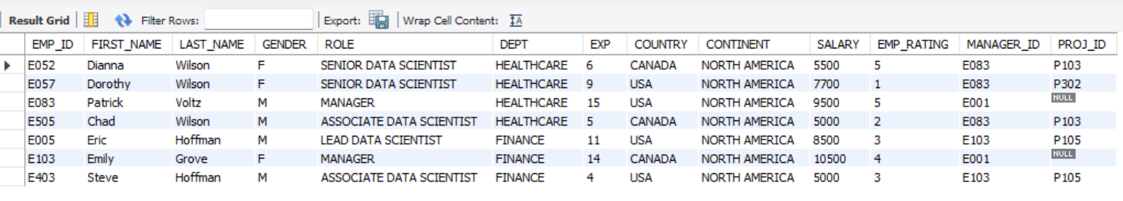
Task 8 to write a query to list employee details such as EMP_ID, FIRST_NAME, LAST_NAME, ROLE, DEPARTMENT, and EMP_RATING grouped by dept. Also include the respective employee rating along with the max emp rating for the department.
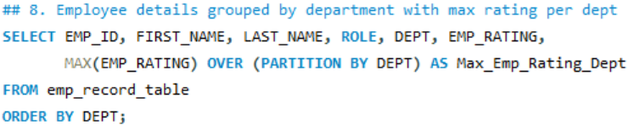
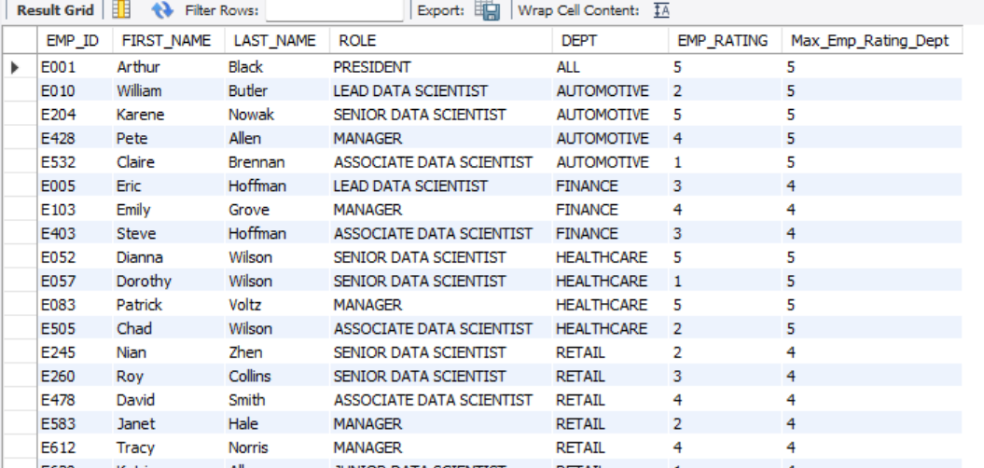
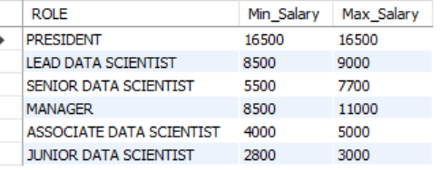
Task 9 to write a query to calculate the minimum and the maximum salary of the employees in each role. Take data from the employee record table.
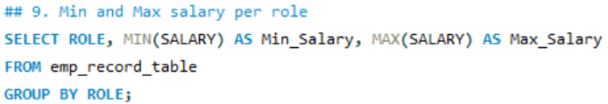

Task 10 to write a query to assign ranks to each employee based on their experience. Take data from the employee record table.
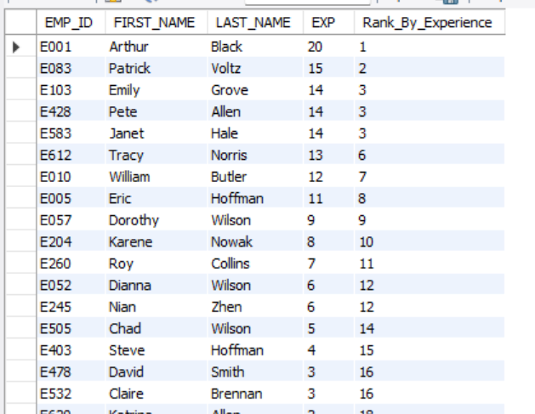
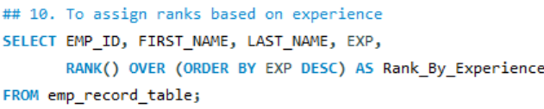

Task 11 to write a query to create a view that displays employees in various countries whose salary is more than six thousand. Take data from the employee record table.
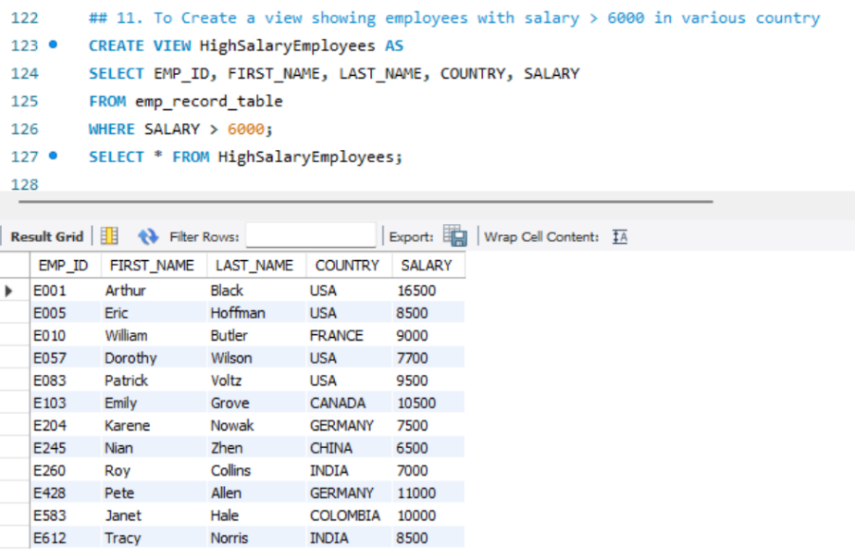

Task 12 to write a nested query to find employees with experience of more than ten years. Take data from the employee record table.
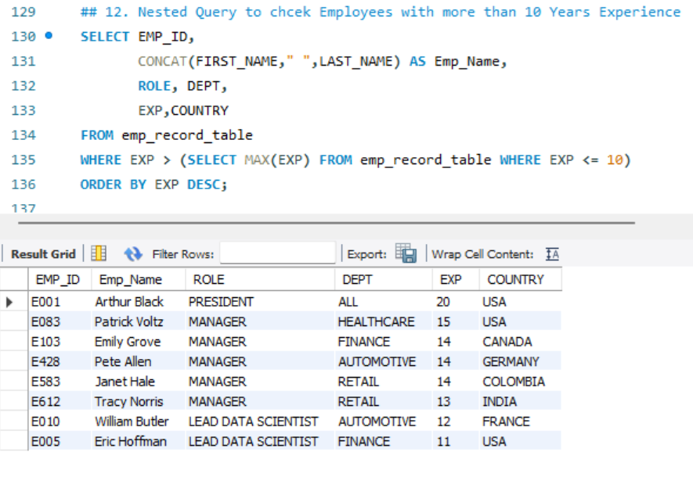
Task 13 to write a query using stored functions in the project table to check whether the job profile assigned to each employee in the data science team matches the organization’s set standard.
The standard being:
For an employee with experience less than or equal to 2 years assign 'JUNIOR DATA SCIENTIST',
For an employee with the experience of 2 to 5 years assign 'ASSOCIATE DATA SCIENTIST',
For an employee with the experience of 5 to 10 years assign 'SENIOR DATA SCIENTIST',
For an employee with the experience of 10 to 12 years assign 'LEAD DATA SCIENTIST',
For an employee with the experience of 12 to 16 years assign 'MANAGER'.
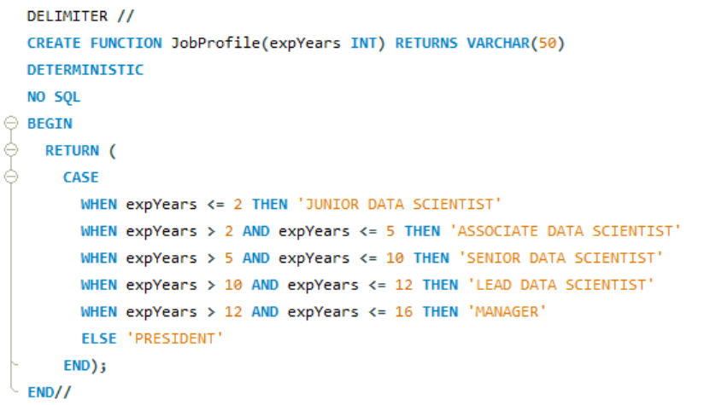
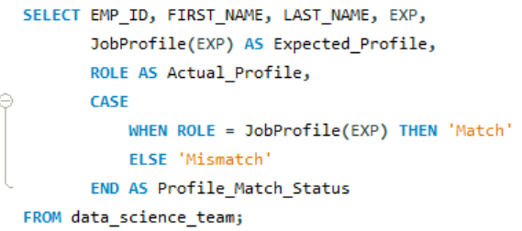
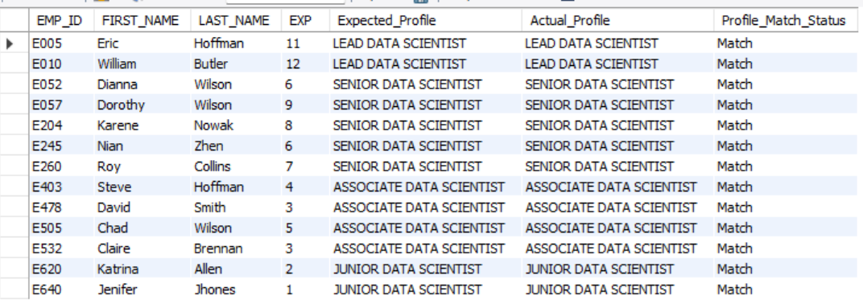
Task 14 to create an index to improve the cost and performance of the query to find the employee whose FIRST_NAME is ‘Eric’ in the employee table after checking the execution plan.
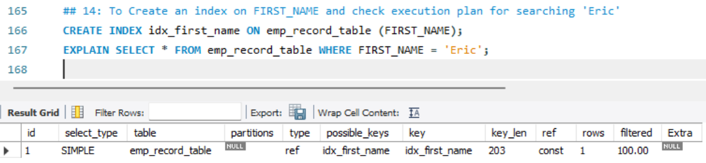
Task 15 to write a query to calculate the bonus for all the employees, based on their ratings and salaries (Use the formula: 5% of salary * employee rating).
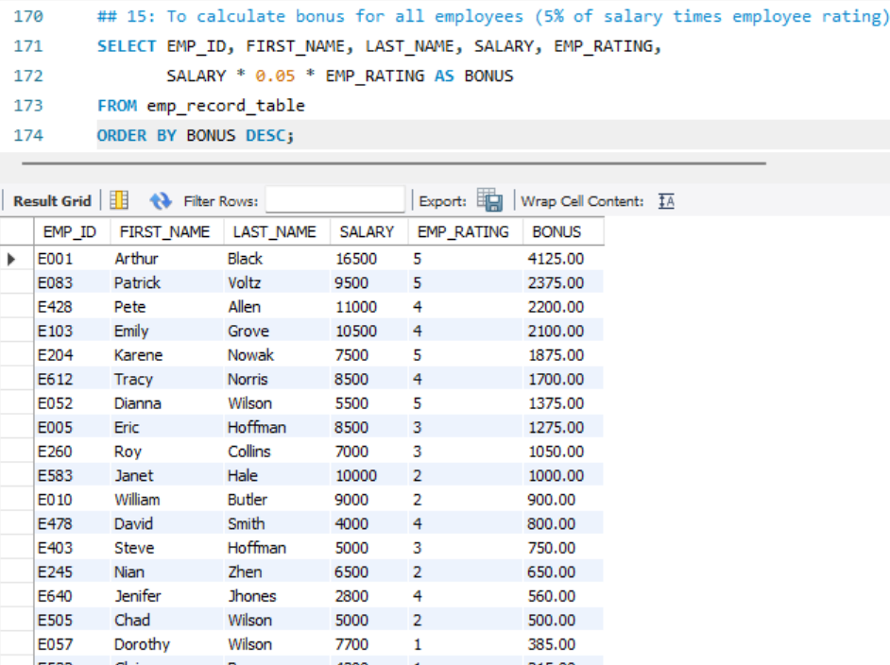
Task 16 to write a query to calculate the average salary distribution based on the continent and country. Take data from the employee record table.
